**Unlocking Insights into the Global Air Transportation Network with Tableau.**

**1.Introduction:**

* 1. **over view**
* **Air transport is one of the fastest modes of public transport which connects international boundaries. Air transport allows people from different countries to cross international boundaries and travel other countries for personal, business, medical, and tourism purposes.**
* **It is very expensive due to the high cost of fuel. It is the only mode of transport to reach the most remote and distant areas especially where there are no roads and railways**
  1. **Purpose**
* **The airplane is much faster than a car, truck, train or ship, making it the ideal transportation system for transporting goods in the shortest possible time.**
* **Air transportation is the movement of people, goods, and mail by aircraft, including commercial airlines, cargo airlines, and other air transport service providers. It involves the use of airplanes, helicopters, and other types of aircraft to transport passengers, cargo, and other goods between different locations, whether domestic or international.**
* **Air transportation plays a critical role in connecting people and businesses around the world, providing faster and more efficient transportation options than other modes of transportation. It is used for various purposes, such as business and leisure travel, the delivery of time-sensitive goods, and emergency response and rescue missions.**
* **Air transportation involves various components, such as air traffic control systems, airport operations, airline operations, aircraft manufacturing and maintenance, and regulatory and safety frameworks. All of these components work together to ensure safe and efficient air transport services.**

**2.Problem Definition & Design Thinking.**

**2.1 Empathy Map**

* **Problem Definition: Imagining what it’s like for someone is not the same as understanding what it’s like for someone.Activities such as empathy mapping can build a false impression of understanding. The way to understand your users is not to empathise with them, it’s to experience the world as they do.**
* **Design Thinking: Design thinking is a methodology which provides a solution-based approach to solving problems. It’s extremely useful when used to tackle complex problems that are ill-defined or unknown—because it serves to understand the human needs involved, reframe the problem in human-centric ways, create numerous ideas in brainstorming sessions and adopt a hands-on approach to prototyping and testing**
* 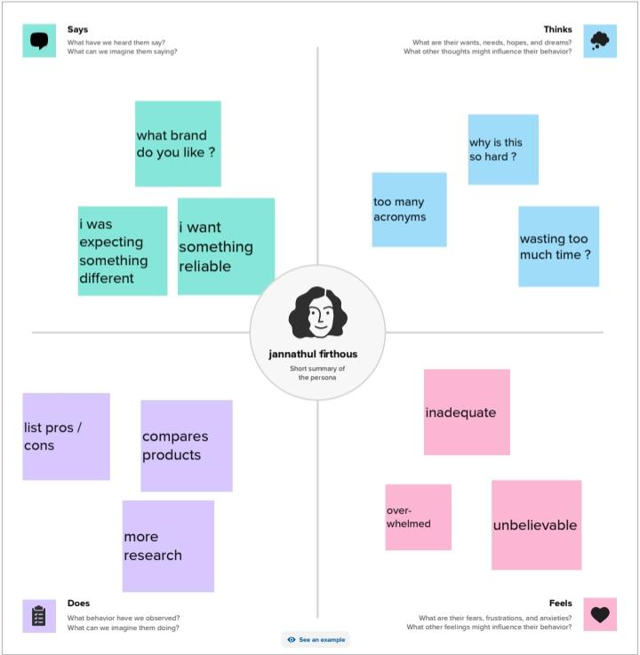**Screen shot:**

**2.2 Brainstorming Map**

* **Ideation: Ideation is often closely related to the practice of brainstorming, a specific technique that is utilized to generate new ideas. A principal difference between ideation and brainstorming is that ideation is commonly more thought of as being an individual pursuit, while brainstorming is almost always a group activity.**
* **An ideation mind map is a visual diagram that helps you organize and structure your thoughts and ideas.**

* **Screen shot:**

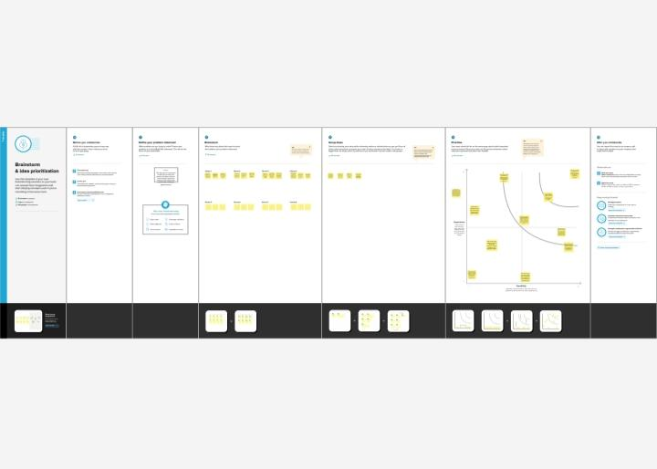

**3. Result:**

* **Empathy mapping helps you go to beyond what users say to understand their behaviors and motivations. These invaluable insights can help you to develop more effective products that speak directly to your users.**
* **It enhances their critical thinking while inspiring their creativity. This innovative method allows students to generate and revise complex lessons better than traditional note-taking. Many research reports conclude that mind maps can offer a positive change of 15% - 23% in students’ cognitive learning**

**4.Advantages & Disadvantages:**

* **Advantages:**

1. **One of the biggest empathy map benefits we’ll discuss is the ability to target a specific audience and unveil their motivations. Empathy maps allow you to isolate a user persona and uncover the rationale behind their actions. This is one of the main reasons why empathy maps are so popular, and allowing businesses to create empathy is a perfect path to creating a product with the target audience in mind.**
2. **The most significant responsibility of an empathy map is to give you accurate insights into consumer behavior. It helps you understand what your users are going through, what users feel about your product, and how they interact with it. Empathy maps provide a deeper concept of user-product relations, including user goals, emotions, interests, and frustrations.**

* **Disadvantages:**

1. **Thoughts quadrant: Here, the teams can analyze the thoughts and attitudes of their users. This includes what the user is thinking about the product or service, what their expectations are, and what their personal biases may be.**
2. **In the Feelings quadrant, teams can focus on the emotions of their users. This includes understanding how their users are feeling about their experience with the product or service, as well as any frustrations or annoyances they may have.**
3. **The Needs quadrant allows teams to analyze the needs of their users. This includes the user’s goals, desires, and motivations.**

**5.Applications:**

* **Creating empathy with your users is one of the most important things you can do from both a business and a user experience perspective.**
* **Understanding your principal user’s motivations, frustrations, and actions is critical to targeting them effectively and providing sustainable solutions for their problems. While not a trivial task, creating empathy is easiest to accomplish via creating an empathy map**
* **Mind map is a useful pictorial thinking tool, which is simple and effective. They show the relationship and hierarchy between ideas through visuals. By coordinating the balanced development between science, art, logic and imagination, mind maps help to explore human brain’s limitless potential. Hence, it is widely used worldwide. It can be applied in fields of memorizing, learning and thinking and so on as illustrated below.**

**6.Conclusion:**

* **As their name suggests, empathy maps simply help us build empathy with our end users. When based on real data and when combined with other mapping methods, they can:**
* **Remove bias from our designs and align the team on a single, shared understanding of the user**
* **Discover weaknesses in our research**
* **Uncover user needs that the user themselves may not even be aware of**
* **Understand what drives users’ behaviors**
* **Guide us towards meaningful innovation**

**7.Future Scope:**

* **Empathy is a crucial skill that plays a significant role in the social and emotional development of students. It allows individuals to understand and share the feelings of others, fostering positive relationships and creating a more inclusive and compassionate society. As educators and parents, we have the responsibility to prioritize empathy development in our children’s education. One effective way to do this is by incorporating empathy-related goals into Individualized Education Programs (IEPs).**
* **Mind maps provide a structured way to capture and organize ideas and information. They help users to understand concepts by breaking them down into their component parts. The technique is used to develop new ideas, or to break down and better understand existing information**

**8.Appendix:**

**https://public.tableau.com/app/profile/jannathul.firthous/viz/DATASETJF_16971878440190/Story1?publish=yes**